Task 1 Linear Regression

Kiara A Ganger
Western Governors University
D208: Predictive Modeling

Author Note
Dataset Churn | Programing Language R | Continuous Variable

Contents
Part I: Research Question 2
A. Purpose of This Data Analysis 2
Part II: Method Justification 2
B. Describe Multiple Linear Regression Methods 2
Part III: Data Preparation 0
C. Summarize The Data Preparation 0
Part IV: Model Comparison and Analysis 2
D. Compare an initial and a reduced linear regression model 2
E. Analyze the data set using your reduced linear regression model 2
Part V: Data Summary and Implications 3
F. Summarize your findings and assumptions 3
Part VI: Demonstration 3
G. Panopto video 3
H. Third-Party Code Sources: 0
I. Non-Code References 0

Part I: Research Question

Purpose of This Data Analysis
- Question:
What are the primary factors that influence customer churn?
- Define The Goals of The Data Analysis
The goal of this analysis is to
    - Find predictors of what can lead to customers churning.
    - Develop a multiple linear regression to predict churning based on those predictions.
    - Give insight to help reduce churning.

Part II: Method Justification

Describe Multiple Linear Regression Methods
- Summarize four assumptions of a multiple linear regression model.
    - Linearity:
There should be a linear relationship between the dependent variable (churn) and each continuous independent variable.
    - Independence:
The residuals (errors) of the model should be independent.
    - Homoscedasticity:
The residuals should have constant variance across all levels of the independent variables.
    - Normality:
The residuals should be normally distributed.
(Bobbitt, The Five Assumptions of Multiple Linear Regression, 2021).
- Describe two benefits of using R in support of various phases of the analysis.
    - R provides statistical analysis tools and awesome visualization packages such as ggplot2 for creating detailed plots and dplyr for data manipulation.
    - The caret package in R is useful for machine learning and model training.
(Harris, 2023).

- Explain why multiple linear regression is an appropriate technique.
Multiple linear regression is appropriate for this analysis because it helps in understanding the relationship between the dependent variable (churn) and multiple continuous independent variables. It can define the effect of each predictor on the likelihood of churn. Multiple linear regression is also useful for making predictions. “Multiple linear regression is preferable when the outcome is influenced by more than one factor because it can account for the impact of multiple variables simultaneously” (Solomon, 2024)

Part III: Data Preparation

Summarize The Data Preparation
- My Data cleaning goals is to insure that:
    - There are no duplicates in the data.
    - All missing values are imputed or removed.
    - Remove and adjust any outliers.
    - And convert the churn column in a numeric variable using binary encoding.
    - Annotated Code (Ganger, 2024): (The codes I used are from my D206 class)
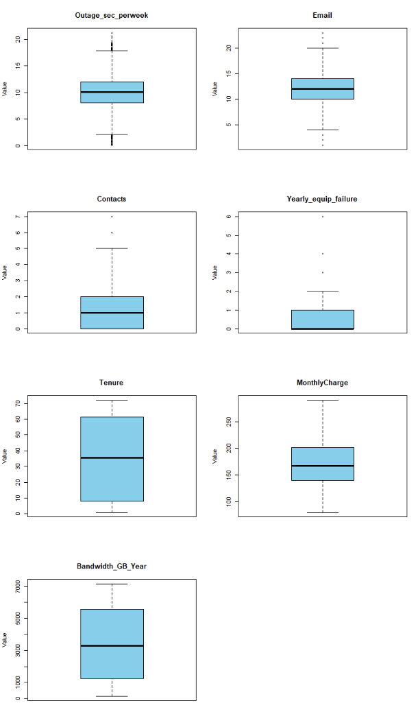
1. # Load necessary libraries
2. library(tidyverse)
3. library(ggplot2)
4. library(caret)
5.
6. # Load data
7. churn <- read.csv("C:/Users/kiara/OneDrive/WGU MSDA/churn_clean.csv")
8. View(churn)

10. #Getting to know the DATA
11. summary(churn)
12.
13. # Detecting Duplicates
14. duplicates <- duplicated(churn)
15. duplicate_count <- sum(duplicates)

16. #Print the results
17. print(duplicate_count)
18.
19. # Find any missing values
20. missing_per_column <- colSums(is.na(churn))
21. # Print results
22. print(missing_per_column)
23.
24. # Remove outliers in continuous variables
25. independent_vars <- c('Outage_sec_perweek', 'Email', 'Contacts', 'Yearly_equip_failure', 'Tenure', 'MonthlyCharge', 'Bandwidth_GB_Year')
26. churn <- churn %>%
27. filter(if_any(all_of(independent_vars), ~ abs(. - mean(.)) <= 3 * sd(.)))

29. # Confirm outlier removal
30. par(mfrow = c(4, 3)) # Set up a multi-panel plot
31. for (col in independent_vars) {
32. boxplot(
33. churn[[col]],
34. main = col,
35. ylab = "Value",
36. col = "skyblue",
37. border = "black"
38. )
39. }
40. # No duplicates, missing values found. Outliers taken care of
- Summary Statistics of Variables
    - Dependent Variable:
Churn
    - Independent Variables:
Outage_sec_perweek, Email, Contacts, Yearly_equip_failure, Tenure, MonthlyCharge, Bandwidth_GB_Year
    - Summary statistics code:
- summary(select(churn, Churn, all_of(independent_vars)))
    - Screen Shot:
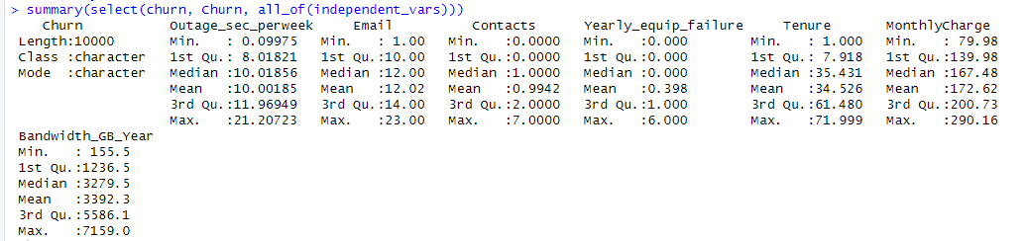
- Univariate and Bivariate Visualizations:
    - Code:
1. # Univariate visualizations
2. for (var in independent_vars) {
3. p <- ggplot(churn, aes(x = .data[[var]])) +
4. geom_histogram(binwidth = 30, fill = 'blue', color = 'black', alpha = 0.7) +
5. xlab(var) +
6. ggtitle(paste('Histogram of', var)) +
7. theme_minimal()
8.
9. print(p)
10. }
11.
12. # Univariate visualization for 'Contacts'
13. contacts_plot <- ggplot(churn, aes(x = Contacts)) +
14. geom_histogram(binwidth = 1, fill = 'blue', color = 'black', alpha = 0.7) +
15. xlab('Contacts') +
16. ggtitle('Histogram of Contacts') +
17. theme_minimal()
18.
19. print(contacts_plot)
20.
21. # Univariate visualization for 'Yearly_equip_failure'
22. yearly_equip_failure_plot <- ggplot(churn, aes(x = Yearly_equip_failure)) +
23. geom_histogram(binwidth = 1, fill = 'blue', color = 'black', alpha = 0.7) +
24. xlab('Yearly Equipment Failure') +
25. ggtitle('Histogram of Yearly Equipment Failure') +
26. theme_minimal()
27.
28. print(yearly_equip_failure_plot)
29.
30. # Univariate visualization of Churn
31. ggplot(churn, aes(x = factor(Churn))) +
32. geom_bar() +
33. xlab('Churn') +
34. ylab('Count') +
35. ggtitle('Distribution of Churn')
36.
37. # Bivariate visualizations using scatterplots
38. churn_biv <- churn %>%
39. select(Churn, all_of(independent_vars)) %>%
40. pivot_longer(cols = -Churn, names_to = "Variable", values_to = "Value")

41. ggplot(churn_biv, aes(x = factor(Churn), y = Value)) +
42. geom_jitter(width = 0.2, height = 0, alpha = 0.5) +
43. facet_wrap(~ Variable, scales = "free_y") +
44. xlab('Churn') +
45. ylab('Value') +
46. ggtitle('Scatter Plots of Independent Vars vs. Churn') +
47. theme_minimal()
48.
    - Screen Shot:
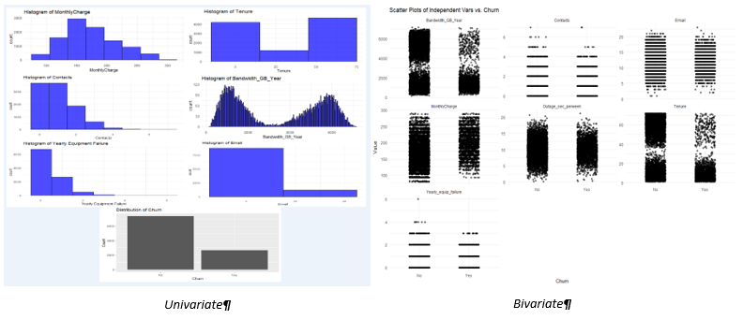
- Describe your data transformation goals and steps.
    - Goals
  - Standardize continuous variables:
Convert continuous variables to z-scores to ensure they have a mean of 0 and a standard deviation of 1.
  - Encode the categorical variable:
Convert the Churn variable into a binary numeric format suitable for regression analysis.

    - Steps
Frist I will normalize the variables. This is to help bring all the continuous variables to a common scale without messing up the differences in the ranges. This is done by converting the variables to its z-score.
Then I will turn Churn in 1s and 0s
    - Code
1. # Function to standardize variables
2. standardize <- function(x) {
3. return((x - mean(x, na.rm = TRUE)) / sd(x, na.rm = TRUE))
4. }
5.
6. # Apply standardization
7. churn_standardized <- churn %>%
8. mutate(across(all_of(independent_vars), standardize))
9.
10. # Encode 'Churn' as binary
11. churn_standardized <- churn_standardized %>%
12. mutate(Churn = ifelse(Churn == 'Yes', 1, 0))
13.
14. # Display the first few rows of the transformed dataset
15. head(churn_standardized)
16.
- Prepared data set
    - View document . churn_standardized

Part IV: Model Comparison and Analysis

Compare an initial and a reduced linear regression model
- Construct an initial multiple linear regression model
I will contrast an initial multiple linear regression model with the following code (Bobbitt, How to Perform Multiple Linear Regression in R, 2019).
1. # Set seed for reproducibility
2. set.seed(123)
3.
4. # Initial Multiple Linear Regression Model
5. initial_model <- lm(Churn ~ Outage_sec_perweek + Email + Contacts + Yearly_equip_failure + Tenure + MonthlyCharge + Bandwidth_GB_Year, data = churn_standardized)
6.
7. # Summary of the initial model
8. summary(initial_model)
9.
- Feature Selection Procedure
To simplify our initial model, I will use the stepwise regression method with AIC. This method will help me decide which variables to keep and which to remove and AIC will allow the modlel to be balanced using the goodness of fit (Bobbitt, A Complete Guide to Stepwise Regression in R, 2019). Using stepwise regression with AIC helps us achieve a model that is accurate.
1. # Stepwise regression to reduce the model
2. reduced_model <- step(initial_model, direction = "both", trace = FALSE)
3.
4. # Summary of the reduced model
5. summary(reduced_model)
- Provide models
    - . Code for the comparison of the initial and reduced models.
1. # Stepwise regression to reduce the model
2. reduced_model <- step(initial_model, direction = "both", trace = FALSE)
3.
4. # Summary of the reduced model
5. summary(reduced_model)
6.
7. # Comparing AIC values of the initial and reduced models
8. aic_comparison <- data.frame(
9. Model = c("Initial Model", "Reduced Model"),
10. AIC = c(AIC(initial_model), AIC(reduced_model))
11. )
12.
13. print(aic_comparison)
    - Screenshot of comparison of the initial and reduced models.
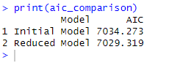

Analyze the data set using your reduced linear regression model
- Explain your data analysis process.
I compared the initial and reduced linear regression models using AIC as my evaluation metric .The outcome shows that the reduced model has a lower AIC value meaning a better balance between fit and complexity. This shows that the stepwise regression successfully identified and removed unnecessary variables. Giving me a simpler and more meaningful model.
- Provide the output and calculations of the analysis.
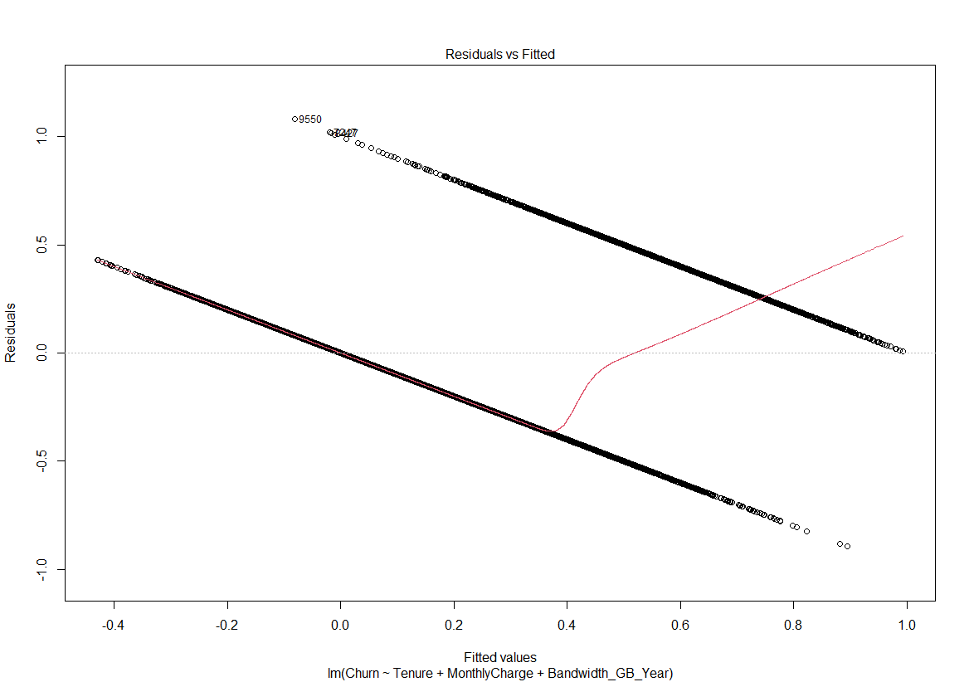
    - a residual plot

    - The model’s residual standard error
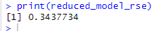
- Provide an executable error-free copy of the code.
Please see attached document Task 1 Code.R

Part V: Data Summary and Implications

Summarize your findings and assumptions
- Discuss the results of your data analysis, including the following elements:
    - Regression equation for the reduced model
Churn=β0+β1×Outage_sec_perweek+β2×Email+β3×Contacts+β4×Yearly_equip_failure+β5×Tenure+β6×MonthlyCharge+β7×Bandwidth_GB_Year
Here, 𝛽0is the intercept, and 𝛽1,𝛽2,…,𝛽7 are the coefficients for each independent variable.
    - Interpretation of the coefficients
Each coefficient represents the expected change in the Churn variable for a one-unit change in the corresponding independent variable, holding all other variables constant. For example:
    - β1(Outage_sec_perweek): A positive value indicates that as the outage seconds per week increase, the likelihood of churn increases.
    - β2(Email): A negative value indicates that as the number of emails increases, the likelihood of churn decreases.
    - The statistical and practical significance of the reduced model
  - Statistical Significance:
The reduced model was chosen based on the AIC, which balances the model fit and complexity. The reduced model's lower AIC value compared to the initial model shows it is statistically more efficient.
  - Practical Significance:
The reduced model is simpler, making it easier for stakeholders to understand what are the keys that effect churn. It retains only those variables that contribute most significantly to explaining churn, making decision-making more effective.
    - the limitations of the data analysis
  - Data Quality
The analysis could be limited by the quality of the data. Missing values and Outliers may have been managed but can still affect the results due to human error.
  - Validity
We are only limited to the information on this dataset. So the performance can change has more data is added.
- Recommend a course of action based on your results.
    - Reduce Outages
  - They should focus on reducing outages, because the outcome shows that outage times are associated with higher churn
    - Pricing
  - Offering discounts for long-tenure customers might help in retaining them.
    - Targeted Interventions
  - Suggest they use the reduced model to identify at risk customers and create strategies to retain them.

Part VI: Demonstration

Panopto video
Link: Wed May 29 2024 3:05:15 PM (panopto.com)

Sources

Third-Party Code Sources:
Bobbitt, Z. (2019, April 27). A Complete Guide to Stepwise Regression in R. Retrieved from statology: https://www.statology.org/stepwise-regression-r/
Bobbitt, Z. (2019, May 11). How to Perform Multiple Linear Regression in R. Retrieved from statology: https://www.statology.org/multiple-linear-regression-r/#:~:text=The%20basic%20syntax%20to%20fit%20a%20multiple%20linear,disp%20%2B%20hp%20%2B%20drat%2C%20data%20%3D%20data%29
Ganger, K. (2024). Task 1 D206.

Non-Code References
BOBBITT, Z. (2021, November 16). The Five Assumptions of Multiple Linear Regression. Retrieved from statology: https://www.statology.org/multiple-linear-regression-assumptions/
Harris, J. (2023, September 20). Advantages and Disadvantages of R programming. Retrieved from theknowledgeacademy: https://www.theknowledgeacademy.com/blog/advantages-and-disadvantages-of-r-programming/
Solomon, M. (2024, March 21). Beginner’s Guide to Multiple Linear Regression. Retrieved from Martin Solomon, Machine Learning Specialist: https://martinsolomon.io/guides/multiple-linear-regression/#:~:text=Multiple%20linear%20regression%20helps%20predict%20outcomes%20by%20analyzing,making%20it%20an%20essential%20skill%20for%20data%20scientists.

